Year 9 History: The RSL Virtual War Memorial Project

This term, Year 9 History students partnered with the Returned & Service League to bring to life the experiences of World War I soldiers through the Virtual War Memorial Program.

“This project provides students an insight into the lives of those who enlisted,” said Andrew Glasson who’s Year 9 History class piloted the program.

“Students selected a soldier, in some instances a relative or a resident from the Campbelltown area, and used a range of websites to find primary sources to piece together the soldier’s life before, at, and, for those fortunate enough, post war.”

Students used Australian Imperial Forces forms and service records, personal letters and photos to understand the experiences of their soldier. Students then consolidated this information into a biography, publishing it on the RSL’s Virtual War Memorial.

“The experiences of eighteen soldiers were immortalised by the students who submitted,” shared Andrew, “adding value to the public record, honouring contributions of those that fought and of those that supported the war efforts from home.”

“Through their experiences, students further established effective literacy and research skills and developed an insight into a period of history that contributed to Australia’s growing sense of national identity.”

“This project, and our partnership with the RSL to participate in it, has been a great opportunity to contextualise and bring History to life.”

Year 9 History students in the new semester will continue to participate in this exciting collaborative project.

If you are interested in exploring the RSL’s Virtual War Memorial, it can be accessed at https://rslvirtualwarmemorial.org.au/

Published students and soldiers:
Claudia Arbucci, Cyril Morrison ADAIR
Matthew Baker, Arthur Ernest Leonard BAKER
James Candelaria, James Allan ARNOTT
Emily Cunningham, Thomas William CUNNINGHAM
Darcey Farmer, Frederick Thomas WATSON
Jack Flavel, Francis James FLAVEL
James Fricker, James AITCHISON
Cameron Lill, Arthur Jack ADDISON
Samuel McAlpine, Percy Francis WEST
Alyssa Misailidis, Frank Douglas Craig SOUTH
Chelsea Nelson, Clifford Augustine NELSON
Tatenda Nyaruwe, Frederick Oswald AARONS
Afton Penrith, John William MURPHY
Ethan Rowe and Stefan Tiburzi, Robert William TANDY
Jaiden Saunderson, Coleman ABELSON
Tamika Shaw, D'Arcey Richard Nottingham SHAW
Gemma Smith, Alfred Eric COLSON
Caitlin Wright, John Henry WRIGHT

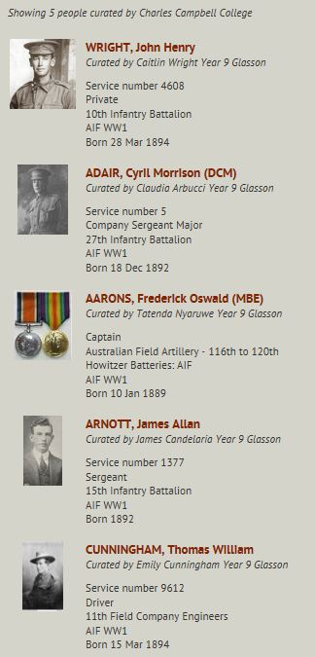

Images from the RSL homepage

