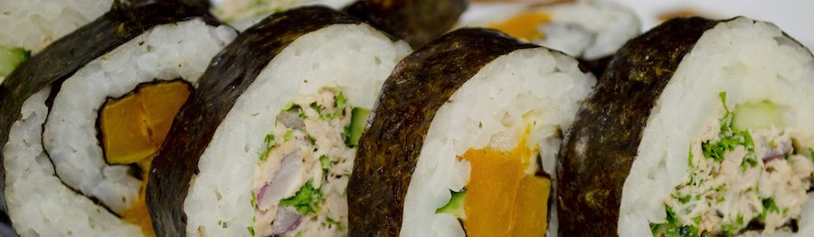

Rory's School Lunches will be running an ongoing weekly Special Sushi Day at our school!

Sushi will be available to pre-order in 3 popular flavours via the QKR app, it will be made fresh each morning by Rory's Chefs and will be delivered to your child via the normal lunch order delivery system from the Rory's Canteen.

The link will take you to the Rory's Website and give you more information regarding pricing, flavours and how to order.

http://rorys.com.au/2017/06/special-sushi-days/

If you require any further information please contact Rory's School Lunches directly.

